ITCSI030 Cyber Security Practical Project

Project Title: **RFID and Motion Detection Based Access System**

New Era Institute of Vocational

And Continuing Education

Subject: ITCSI 030 Cyber Security Practical Project

Project Title: **RFID and Motion Detection Based Access System**

Student Name: Mah Sung Kit

Student ID: 2220035-ITCSI

Due Date: 1 February 2024

Project Supervisor: Gan Boon Siang

**Preface**

In the context of evolving technology, the integration of different components into innovative projects not only defines the strength of modern engineering, but also opens the door to a new era of possibilities. This project aims to demonstrate the seamless synergy between these technologies, providing a reliable and efficient means of managing access to designated areas.

This project, with its focus on integration, security and efficiency, is an excellent example of how technology can be utilized to create an advanced access control system. The integration of Radio Frequency Identification (RFID) technology with motion detection capabilities provides a strong foundation for an advanced access control system.

My upcoming project, title “RFID and Motion Detection Based Access System", fully embodies the spirit of innovation through the clever integration of the Arduino IDE, ESP32 CAM, PIR Motion Sensor HC-SR501, MFRC522, as well as Python and MySQL servers!

In this access control system project, Arduino IDE acts as a code editor, ESP32 CAM is responsible for image capture and communication, PIR Motion Sensor is used for motion detection, and MFRC522 implements RFID technology. Python script communicates with MySQL server to record RFID data and process image information. The entire system works in tandem with these components to enable secure management and recording of access to designated areas. Whether triggered by RFID touch or motion detection, the system is able to effectively record and process relevant information, providing a solid foundation for an efficient access control system.

**Acknowledgements**

First and foremost, a heartfelt thank you to the Arduino community for providing a powerful and versatile platform. The Arduino IDE has played a key role in shaping the intelligence behind our access control system, and the wealth of knowledge shared by the community is an invaluable resource.

The contribution of the ESP32 CAM development team deserves a special mention. They worked to create a powerful and feature-rich microcontroller with integrated camera functionality that greatly enriched my project!

The creators of the PIR Motion Sensor HC-SR501 played a key role in enhancing the security of my access control system. Their innovative sensor technology made reliable motion detection possible and made a significant contribution to the success of the project.

My appreciate the Python community for the flexibility and ease of integration of their language. Seamless communication with the MySQL server using Python scripts has played a key role in realizing a powerful and efficient mechanism for RFID data processing!

Finally, thank you to my mentors and friends whose insights and encouragement have been invaluable throughout the development process. Your support has galvanized my determination to overcome obstacles and bring this project to a successful conclusion!

This project is a testament to the power of collaboration and the strength of a diverse community working towards a common goal. Every contribution, big or small, played a vital role in the success of the RFID and motion detection based access control system!

Table Of Contents

Chapter 1 1

1.1Motivation 2

1.2Project Scope 3

1.3 Project Objectives 3

Chapter 2: Literature Review 4

2.1 Comparison with Existing Projects 4

2.2 improvements in My Project 6

Chapter 3 Methdology 7

3.1 Work Plan 7

3.2 Gantt Chart 8

3.3 Project Resources 9

Chapter 4 Design and Implementation 10

4.1 Flow Diagram 10

4.2 Circuit Diagram 13

4.3 Coding 16

4.3.1 PIR_ESP32_WHATSAPP.ino 16

4.2.2 Rfid_python_new.ino 21

4.2.3 Connection.php 24

4.2.4 Authentication.php 25

4.2.5 CountimagerFile.php 27

4.2.6 Download.php (access record data) 28

4.2.7 Loadphoto.php 30

4.2.8 Loadphoto.php (delete function) 31

4.2.9 Sarch.php 33

4.3 Budget 34

Chapter 5 Testing Result 36

Chapter 6 Future Enhancements 56

Chapter 7 Summary and Conclusion 57

Appendices 58

Reference 58

PROJECT PROPOSAL FORM 59

PROJECT SPECIFICATION FORM (PSF) 60

Project Weekly Report 64

# Chapter 1

Access control refers to the methods and systems used to regulate and restrict access to a specific area or system. In the context of physical security, various methods such as Closed-Circuit Television (CCTV), access cards, fingerprint authentication systems etc. are used to ensure controlled access.

Below is an organized summary with added explanations for RFID, ESP32 CAM, motion detection, and the database's purposes.

1. Arduino Uno R3 It provides the necessary processing power and interfaces to manage the overall security system's operation.
2. RFID cards or tags enhance security by enabling wireless identification through RFID technology.
3. ESP32 CAM, a powerful microcontroller module with Wi-Fi and a camera, is used to capture images.
4. Motion detectors add an extra layer of security by detecting motion to trigger specific actions such as capturing images or recording events.
5. MySQL database stores user credentials, access logs and associated images, providing administrators with easy review and audit capabilities to ensure a comprehensive and reliable record of access to specific areas.

The integration of modern technologies opens up new possibilities for innovation. In my project, I combined components such as the Arduino IDE, ESP32 CAM and RFID to create a fast, easy and advanced system. These components form an innovative and efficient system for a variety of application scenarios. In this project this system integrates a variety of functions such as access control, attendance recording and motion image capture to provide users with a convenient and efficient solution. This multi-layered approach not only improves the ease of use of the system, but also strengthens security, making it suitable for specific situations where access needs to be strictly controlled.

1.1 Motivation

The motivation for choosing this project stems from the growing demand for contemporary advanced security access control systems and the desire to contribute to the evolution of technology to solve real security challenges.

There is a growing demand for contemporary advanced security access control systems, especially in places such as universities, schools, shopping centers and office buildings. As a user, I realized the importance of security systems and therefore chose this topic. In my observations, I have looked at the balance between the cost and functionality of the equipment to ensure that it is affordable. At the same time, I became curious about the components and structures used in security systems, which prompted me to carry out an in-depth study, build a concept and define a prototype to fit the budget. Through this project, I hope to contribute to the evolution of technology to solve real security challenges and meet growing needs!

In this system, hardware and software components are carefully integrated to build an efficient and comprehensive access control solution. the Arduino IDE serves as the control center, the ESP32 CAM captures images when motion is detected, the PIR motion sensor HC-SR501 is responsible for the motion detection, and the MFRC522 RFID module is introduced to enhance the authentication function. A MySQL server integrated via Python is responsible for efficiently handling data communication and storage. This comprehensive integration approach considers not only hardware sensing and capture, but also focuses on system control and data management, thus providing an all-encompassing, safe and reliable access control system that meets the needs of contemporary security challenges.

## 1.2 Project Scope

The scope of the project includes the integration of the Arduino IDE, ESP32 CAM, PIR motion sensor HC-SR501 and a MySQL server for interaction through Python scripting. The system is able to capture images when motion is detected using the ESP32 CAM, process RFID data for user authentication, and securely communicate with the MySQL server through Python scripts.

System Usage and Functionality

Users can install the system in the company office company's important places can be controlled staff and visitors in and out of the maintenance of regional security at the same time can also be installed in the server room to ensure that the server room can only be important personnel in and out of the security, but also through the motion detection function, when the ESP32 CAM detects movement, automatically capture the image, to improve monitoring and security. In addition, the system utilizes RFID authentication to provide an efficient and secure means of identity verification by processing RFID data for user identification, allowing users to quickly and easily access designated areas without the need to carry traditional access cards. In terms of communication, the system utilizes Python scripts to communicate securely with the MySQL server to ensure the confidentiality and integrity of data transfer.

## 1.3 Project Objectives

1. Integrated components: Enables the Arduino IDE, ESP32 CAM, PIR sensors and MySQL server to work together.
2. Motion Detection and Image Capture: Use the PIR sensor to trigger the ESP32 CAM to capture an image.
3. RFID Authentication: RFID Authentication System Developed with Arduino
4. Integrated Access Control: Creates an integrated access control system that combines RFID and motion detection technology to enhance security and user authentication.
5. Server: When a user uses RFID for authentication, the system will automatically record and upload it to the server for storage
6. Data can be exported from the server to document format.

# Chapter 2: Literature Review

In the field of RFID access control and motion detection systems, existing projects are reviewed to learn from experience, find potential improvements, and ensure that the project is innovative. By referring to YouTube videos, Google searches, and related educational materials, we can get richer information.

## 2.1 Comparison with Existing Projects

Embedotronics Technologies [1] in their film created an access control authentication system using ARDUINO UNO R3 board and MFRC522 RFID access control authentication system in combination with Python and transferring the authentication records to a server for storage via Python. In this project I observed that for focusing on the implementation of the access control authentication and the transfer of the authentication records, a good job was done, but more details about the system may be needed, e.g. (remote access to the data is possible) and the presentation of the user interface, e.g. (to receive alerts when the user is using RFID).

The authors of Random Nerd Tutorials [2] have created a message sender using ESP32 that sends messages to WhatsApp, providing a convenient way to notify users. In this project I think it would be possible to use ESP32 to create a message sender that sends messages to both WhatsApp and email, etc. to provide a convenient way to notify users!

In the webpage of elec.cafe.com [3], the authors created a system with motion detection using ESP32-cam and HC-SR501. When there is motion detection, the ESP32-cam sends information over the network for real-time motion detection applications. In this project I think it is possible to use the ESP32-cam and HC-SR501 to create a system with motion detection and send real-time information over the network. It performs well in motion detection and real-time notifications, but may need higher sensitivity to improve accuracy.

In the video of YouTube channel Uteh St [4], the author demonstrates a simple and practical image transfer solution by using the ESP32 camera to take pictures and transfer them to a server. In this project I observed that the simplicity of image transfer is emphasized by using the ESP32 camera to take photos and transfer them to a server. This is useful for scenarios where images need to be recorded. The video also emphasizes the simplicity of image transfer by allowing images to be added to the server with the aim of saving and viewing them at any time.

## 2.2 improvements in My Project

My project will achieve the following goals in the plan.

* While the project is impressive in integrating RFID and motion detection, focusing on RFID and motion detection to make it more versatile and user-friendly provides a good user interface for users. Uploading RFID data to the server allows users to check who is using RFID at a certain time via a web page anytime, anywhere. When uploading the access logs, it is also possible to upload the photos taken by the ESP32-cam to the server for storage.

Based on the research and review

* It seems to me that although this YouTube project has designed an advanced security system, there may be some aspects that lack an in-depth description of the internal integration and interaction of the system (detailed explanations of the code, connecting voltages between circuits, etc.). For this reason I think that in our project we should pay special attention to the communication flow between the components and the detailed explanation of the system integration, in order to make the whole system more transparent and easy to understand, we can also simplify the design of the system and improve the ease of use, so that more users will be able to understand and use the access control system easily.

# Chapter 3 Methdology

## 3.1 Work Plan

Throughout the course of the project, a clear work plan needs to be developed, and the following are the scheduled times and steps of my work plan for the project.

1. Search for references/online research (1 week):
   1. Define the context of the project and related technologies.
   2. Gather information and experience from existing similar projects.
2. Purchasing equipment and browsing equipment (1 week);
   1. Waiting for the equipment to arrive
   2. Welding equipment
3. Setting up the ESP32-CAM and connecting peripheral devices (3 week):
   1. Acquiring and configuring the ESP32-CAM microcontroller
   2. Connecting the Motion Detection Sensor
4. RFID Access Control System (2 weeks):
   1. Writing code for RFID readers
   2. Integrate RFID access control to the whole system.
5. Notification system (1 week):
   1. Develop notification system to send alerts via WhatsApp.
   2. Integrate the notification system into the overall system.
6. User Interface Design (2 weeks):
   1. Creating a graphical user interface (GUI) for viewing access logs (Web Site)
7. Testing and Problem Fixing (1 weeks):
   1. Perform unit and integration tests.
   2. Fix issues that may arise
8. Documentation (1 weeks):
   1. Writing project reports
9. Project Demonstration (1 week):
   1. Demonstrate project functionality and features.
   2. Answer relevant questions and feedback.

## 3.2 Gantt Chart

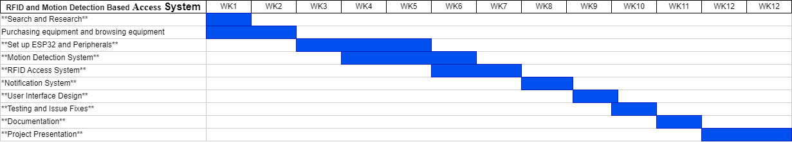

## 3.3 Project Resources

1. Hardware Resources:
   1. Arduino UNO R3 PRO
   2. ESP32-CAM
   3. Motion Detection Sensor (PIR)
   4. MFRC522 RFID Reader
2. Software Resources:
   1. Arduino IDE
   2. XAMPP (MYSQL)
   3. Subline
   4. Visual Studio
   5. Microsoft Word
   6. PowerPoint
3. Human Resources:
   1. Project Mentor: Mr. Gan Boon Siang
   2. Project Member: Mah Sung Kit
4. Information resources:
   1. Google Search Engine
   2. Random Nerd Tutorials
   3. YouTube video reference

Through clear work plans, Gantt charts and effective project resource management, it will be ensured that the project is completed within the stipulated timeframe and meets the desired objectives in a high quality manner.

# Chapter 4 Design and Implementation

## 4.1 Flow Diagram

Part 1 MFRC 522 RFID Diagram

This flowchart is for the operation of MFRC522 you can see in the diagram when successfully connected to the power supply the system will start to operate when there is no RFID contact the system will be on standby when there is a contact the system will identify whether the RFID card is authenticated or not if the RFID card is not in the system the system will light up a red light on the contrary if it is in the system it will light up a green light and send the data to the database.

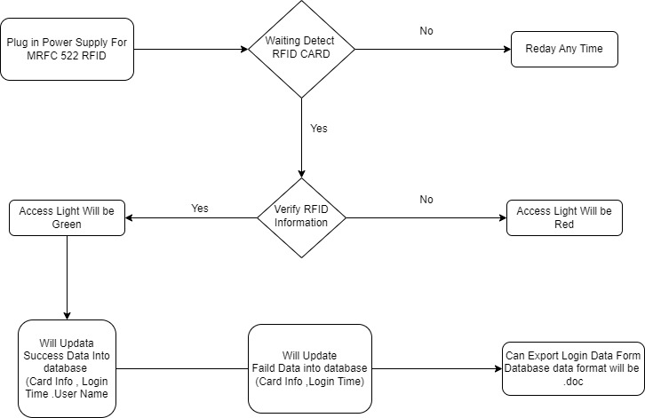

Part 2 ESP32-Cam & Motion Detector Diagram

This flowchart is forESP32-cam and Motion Detector joint operation Firstly, connect the ESP32-cam & Motion Detector to the power supply through the Arduino UNO R3 Next is to wait for the ESP32-cam to connect to the wireless network The Motion Detector will be ready to work When there is no motion detection, the system will be on standby and wait for the motion detection On the contrary, if there is a motion detection, the ESP32-cam will take a photo and send the photo to the server.

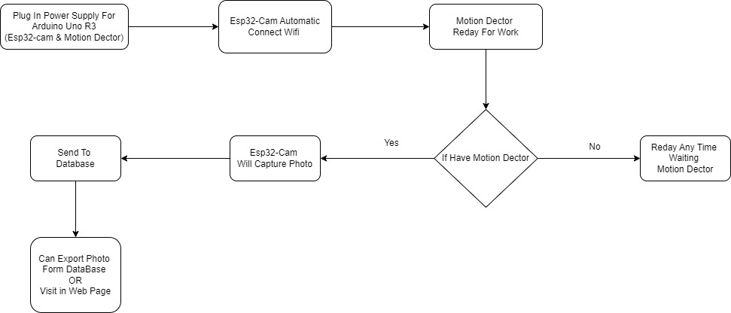

Part 3 Web

This flowchart is for users to log in to the web page to view photos first we first open the web browser and log in when the login fails the system will return to the login page on the contrary when the login succeeds the user will see two interfaces are esp32-cam according to the motion detection of the photos taken at this time for the option to delete or download the photos. View RFID Access Record Users can save the access data in this page.

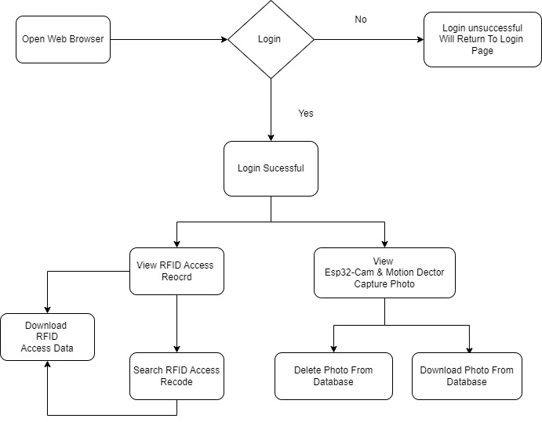

## 4.2 Circuit Diagram

Part 1 – Setup MFRC522

First of all, we will insert the circuits in order according to the arrangement in the picture, when all the circuits have been inserted, we can prepare a data transmission line for the transmission of the Arduino Uno R3 has been saved inside the code written by yourself!

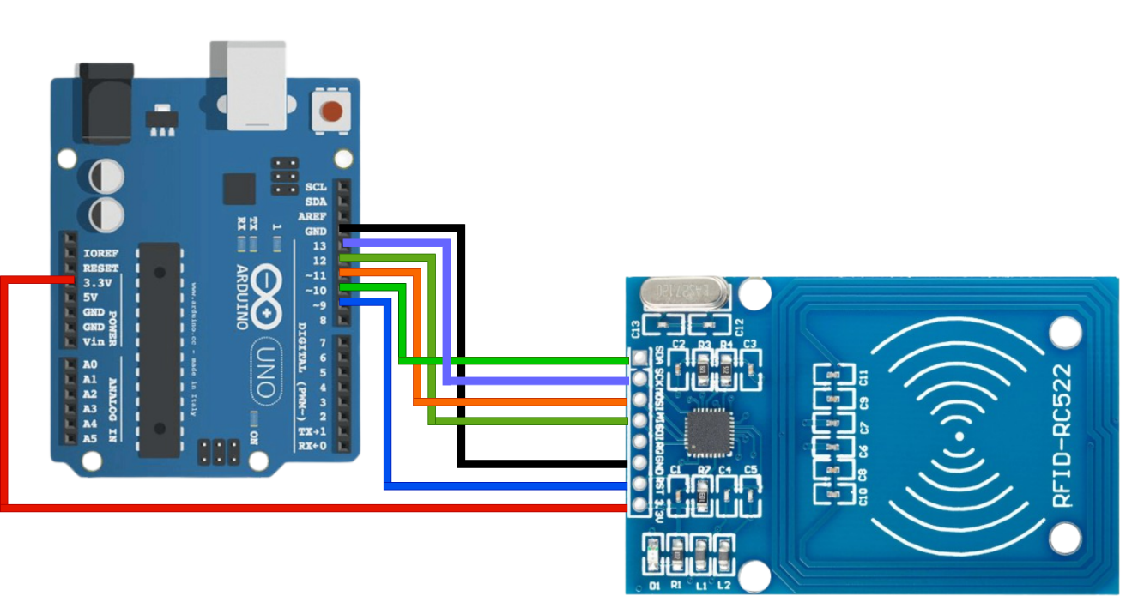

Part 2 Setup PIR(HC-SR505) , ESP32-CAM and Arduino Uno R3 connection

According to the circuit diagram shown in the picture in order to connect this picture is the HC-SR505 and ESP32-CAM connected to the Arduino Uno R3 in this side is to play a role in power supply when all the circuits are connected ready to prepare a cable plugged in to the power can be used and how do we want to see the ESP32-CAM captured picture please see Part3

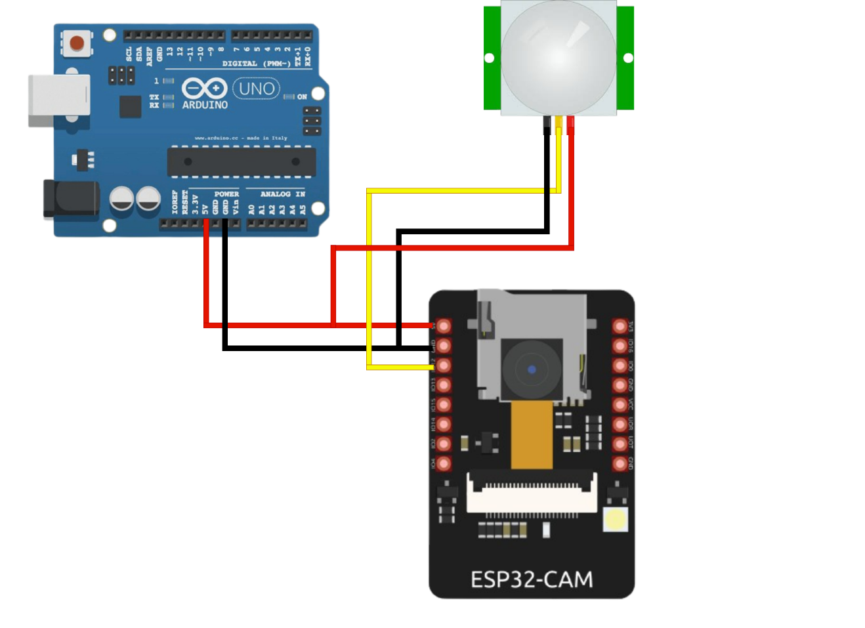

Part 3 Setup the website server

As described in Part 2, when the ESP32-CAM is connected to WIFI, the automatic photo function is activated and uploaded to the server when there is motion detection. Here we need to open the Apache service and the MySQL service through Xampp in order to upload the photos to the server and to view them.

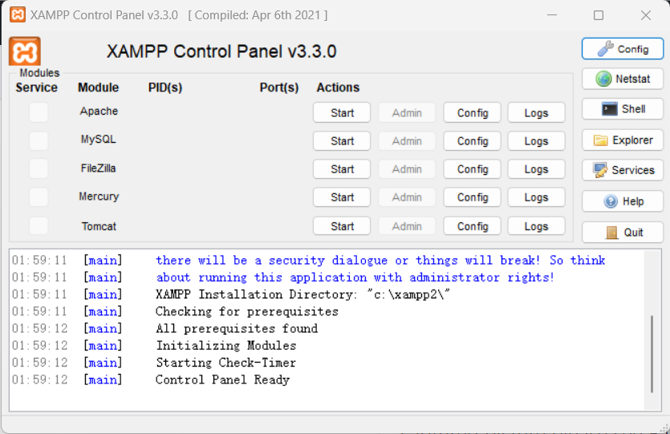

## 4.3 Coding

### 4.3.1 PIR_ESP32_WHATSAPP.ino

This part of the code is part of the sendPhotoToServer function, which is responsible for waiting for the motion detection signal, capturing the photo, and sending a message when the capture is successful. Here is the explanation of this part of the code.

Wait for motion detection signal.

* Use digital Read (PIR_SENSOR_PIN) to detect the signal from the PIR sensor. Loop and wait until motion is detected (the level of PIR_SENSOR_PIN changes to HIGH).
* During the wait, each cycle is delayed by 500 milliseconds.

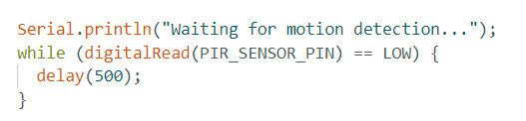

Motion detected and photographed.

* Once motion is detected, output the appropriate prompt message and start capturing photos.
* Use the esp_camera_fb_get() function to fetch the camera buffer, and if the fetch fails, output an error message and end the function.
* If the LED flash is enabled (LED_Flash_ON is true), set the external LED flash to high during photo capture via digital Write.

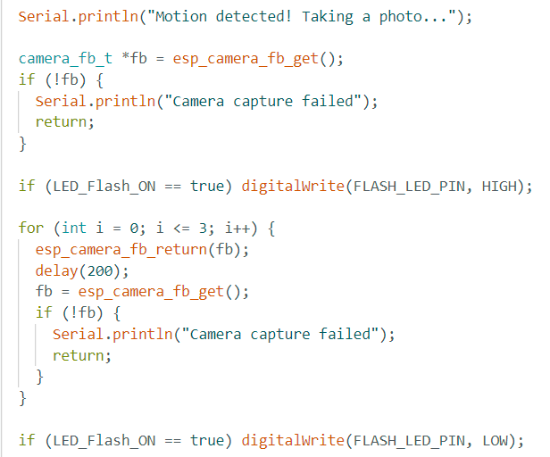

Send a message when there is motion detection.

* After capturing the photo successfully, output the corresponding success message.
* Call the sendMessage function to send a message to WhatsApp.

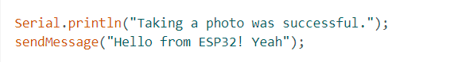

This part of the code defines a function send Message for sending WhatsApp messages. The following is an explanation of this code:

Configures the parameters for WhatsApp to send messages:

* phone Number: the phone number that WhatsApp receives messages from, in international format (in this case a Malaysian number).
* API Key: API key for authentication.



send Message function:

* The send Message function is used to send a WhatsApp message via CallMeBot's API.
* A URL is constructed for sending the message, which includes the phone number to receive the message, the API key and the content of the message to be sent (encoded by the URL Encode function).
* Initiate an HTTP request using the HTTP Client object.
* Send a POST request to CallMeBot's API with the phone number, API key, and message content.
* Check the HTTP response code, if the response code is 200, the message was sent successfully, otherwise output an error message and the HTTP response code.

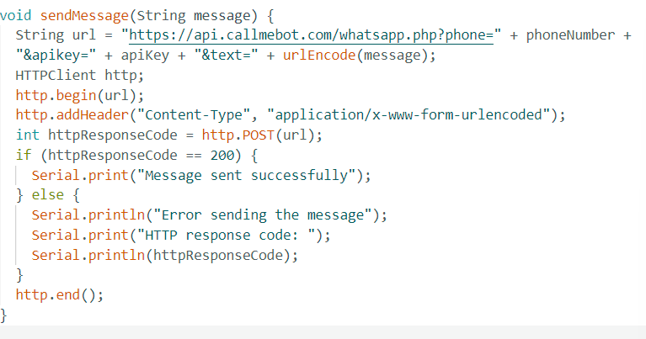

This part of the code involves connecting to the server and constructing and sending multipart/form-data POST requests containing image data. The following is an explanation of this part of the code:

Connects to a server:

* Outputs a message indicating that a connection is being made to the specified server.
* Use client.connect(serverName.c_str(), serverPort) to try to establish a connection with the server.
* If the connection is successful, output a success message.

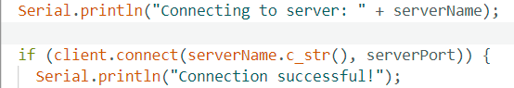

Constructs a POST request:

* Constructs a multipart/form-data POST request for sending image data to the server.
* Defined the header information for the request, including the data separator, form field name, file name, etc.
* Calculated the length of the request body and set the appropriate HTTP request headers.

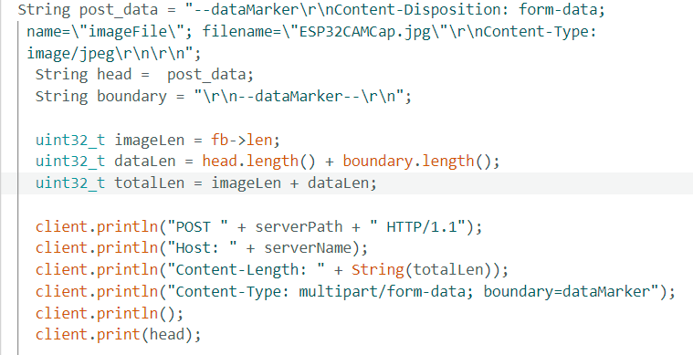

Send image data:

* Use client. Write to send image data to the server in chunks.
* The data is sent in 1024-byte chunks in a loop until all the data has been sent.

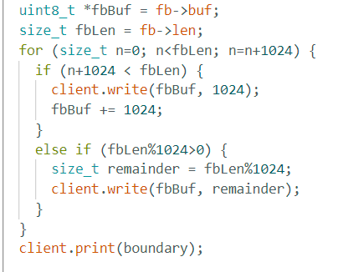

### 4.2.2 Rfid_python_new.ino

This is a sample code for an Arduino, MFRC522 RFID module-based access control system. The following is an explanation of the main parts of the code:

Initialize RFID Module and Network Module

* The setup function initializes the serial communication, SPI, RFID module and sets the LED pins as outputs.
* The owners array contains the pre-defined card ID and card owner information.

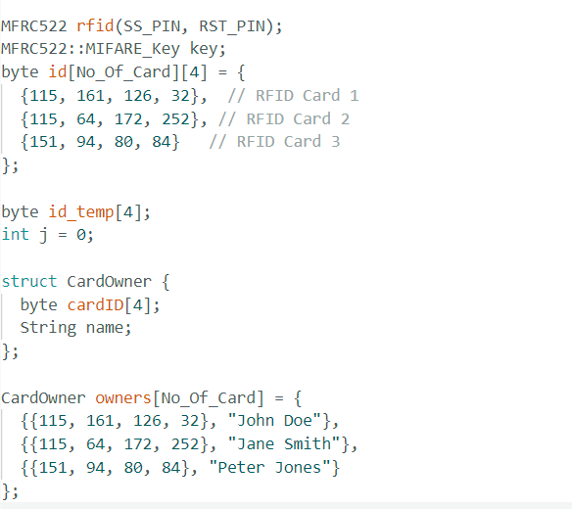

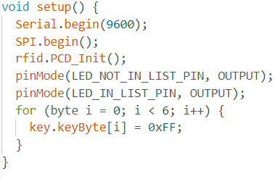

Main loop:

* In the loop function, the card serial number is read by checking if the RFID module has detected a new card.
* The read card serial number is compared with the predefined card ID and if it matches, access is granted, otherwise access is denied.
* The LED is used to indicate whether the card is in the authorized list or not.

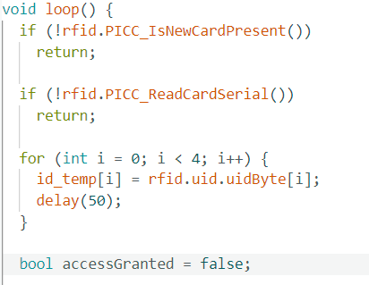

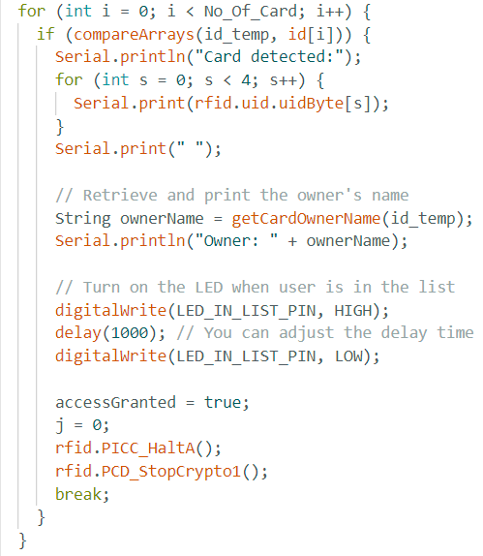

helper functions:

* The getCardOwnerName function gets the name of the card owner based on the card ID.
* compare Arrays function is used to compare two-byte arrays are equal.

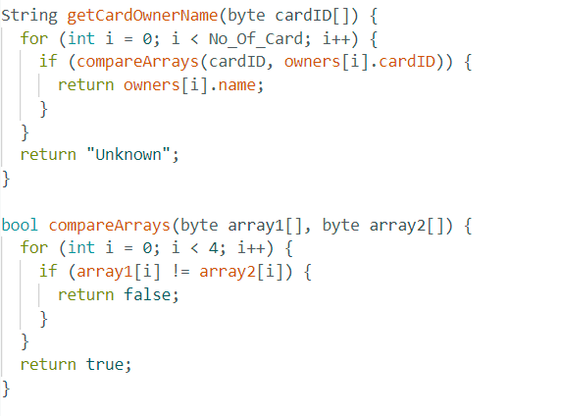

### 4.2.3 Connection.php

This is a simple PHP code snippet for connecting to a MySQL database. Here is an explanation of this code snippet.

Database connection information:

* $host: Host name or IP address of the database server.
* $user: the username to connect to the database.
* $password: Password for connecting to the database.
* $db_name: name of the database to connect to.

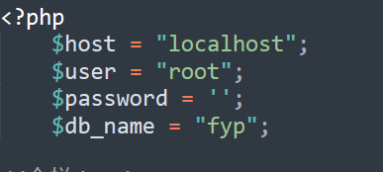

Database Connection:

* Use the mysqli_connect function to create a connection to a MySQL database.
* If the connection fails, an error message is output, and script execution is terminated.

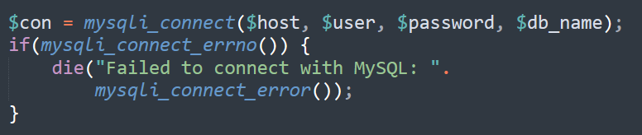

### 4.2.4 Authentication.php

This PHP code is a simple login validation script that checks if the username and password provided by the user matches in the database. Below is an explanation of the code:

Include the database connection file:

* include('connectionn.php'); statement to include the database connection file.



Receive user input:

* $_POST['Uname'] Get the username sent via the POST method.
* $_POST['Pssw'] Get the password sent via POST.



Prevent SQL injection attacks:

* Use the stripcslashes function to remove backslashes.
* Use the mysqli_real_escape_string function to escape usernames and passwords to prevent SQL injection attacks

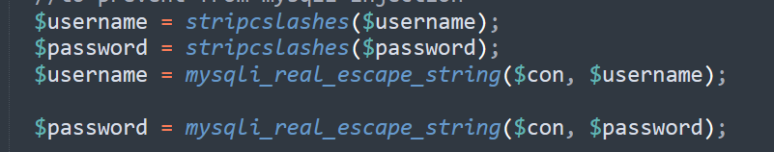

Execute a database query:

* Construct a SQL query statement to select records from the database table named "uifo" that match the username and password provided.
* Use mysqli_query to execute the query.
* Use mysqli_fetch_array to get an associative array of query results.
* Use mysqli_num_rows to get the number of rows in the query result.

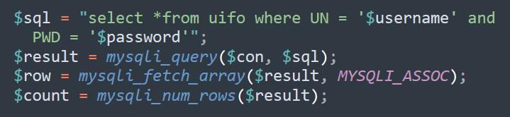

Verify the login and perform the corresponding operation:

* If the number of rows is 1, it means the username and password are matched successfully, output a successful login message, and then use header ("Location: index.php"); redirect to the index.php page.
* If the number of rows is not 1, it means the login failed, output an error message, and then use header ("Location: Login.php"); to redirect to the Login.php page.

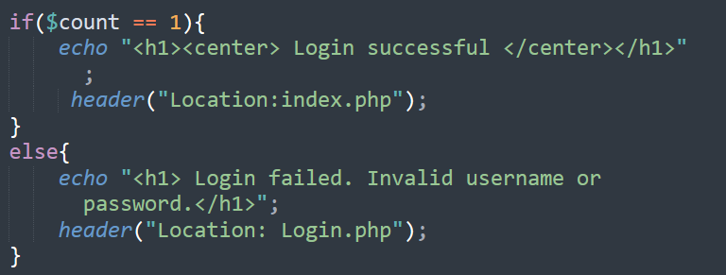

### 4.2.5 CountimagerFile.php

This PHP code receives a command parameter (cmd) via a POST request and if the command parameter is "GTP", counts the number of image files in the specified folder and returns the result. Here is an explanation of the code.

Checks if POST data was received:

* if (!empty($_POST)) is used to check if there is data sent through the POST method



Get command parameters:

* $_POST["cmd"] Get the POST parameter named "cmd", which is the command parameter



Execute the command:

* If the command parameter is "GTP", perform the following:
  1. Set the path to the folder where the image files are stored to $directory.
  2. Use the glob function to count the number of files of a specific type in the folder (in this case, jpeg, jpg, png, gif files)
  3. Return the number of files to the caller.

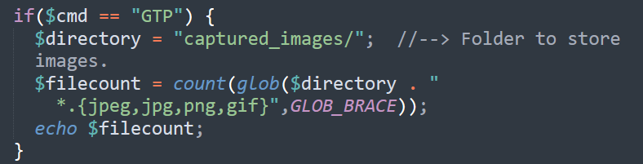

### 4.2.6 Download.php (access record data)

This PHP code does the following.

Include the database connection file:

* The include('connectionn.php'); statement is used to include the database connection file, which should contain information about the database connection.



Defines the download CSV function:

* The downloadFilteredCSV function is used to download filtered data as a CSV file.
* Use the header to set the response header, tell the browser that the file is in CSV format, and set the filename.

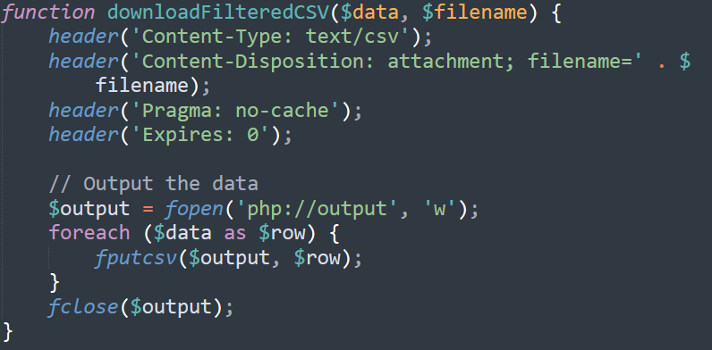

Get search criteria:

* Checks if a search condition named "search" was received via the POST method.
* If there is a search condition, assign it to $searchQuery, otherwise set it to an empty string.



Execute database queries:

* Constructs a SQL query statement to filter the records in the database table based on the search criteria.
* Store the query results in the $data array.

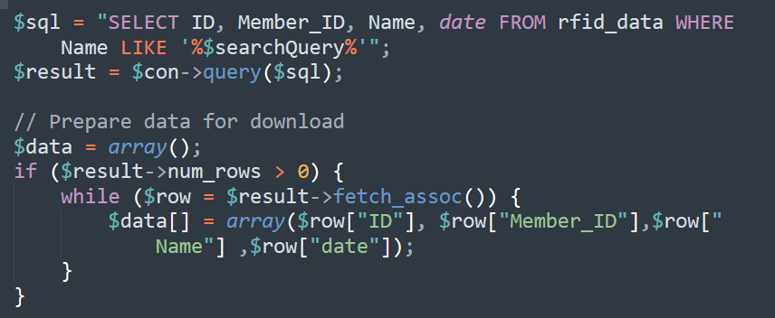

Download CSV file:

* Call the previously defined downloadFilteredCSV function to download the filtered data to the client in CSV format.



### 4.2.7 Loadphoto.php

This PHP code is used to process download requests for image files. Here is an explanation of the code.

An array of image file extensions:

* The $image_extensions array contains the image file extensions that are supported for download, such as "png", "jpg", "jpeg", "gif".

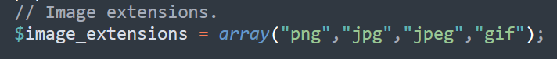

Gets the image file path and type:

* Get the path to the image file to be downloaded from the GET request.
* Use the pathinfo function to get the file extension and convert it to lowercase.

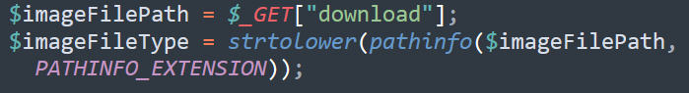

Set the response header required for the download:

* Use the header function to set the response header information of the downloaded file, including file type, file name, etc.

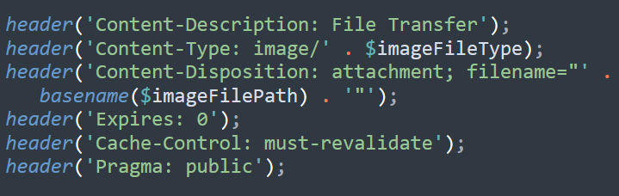

### 4.2.8 Loadphoto.php (delete function)

Checks if there is a delete request:

* Use isset($_GET["delete"]) to check if there is an HTTP GET request named "delete".



Gets the path and type of the image file to be deleted:

* Get the path to the image file to be deleted from the GET request.
* Use the pathinfo function to get the file extension and convert it to lowercase.

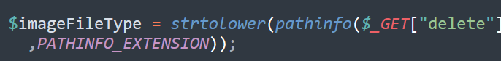

Checks if a file exists with a legal extension:

* Use file_exists to check if the file exists.
* Use in_array to check if the file extension is in the allowed extensions array, and limit the deletion to jpg, png, and jpeg files.

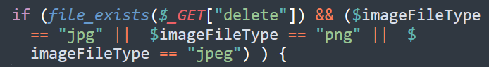

Delete image files:

* Use the unlink function to delete a file at the specified path.



Execute JavaScript code after deletion:

* Use JavaScript code to display modal boxes or perform other user interactions after a successful file deletion.

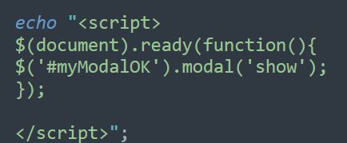

### 4.2.9 Sarch.php

This PHP code does the following.

Include the database connection file:

* include('connectionn.php'); statement to include the database connection file.



Get search criteria:

* Checks if a search condition named "search" was received via the GET method.
* If there is a search condition, assign it to $searchQuery, otherwise set it to the empty string.



Execute database queries:

* Construct SQL query statements to filter records in database tables based on search criteria.
* Output the query results as an HTML table.

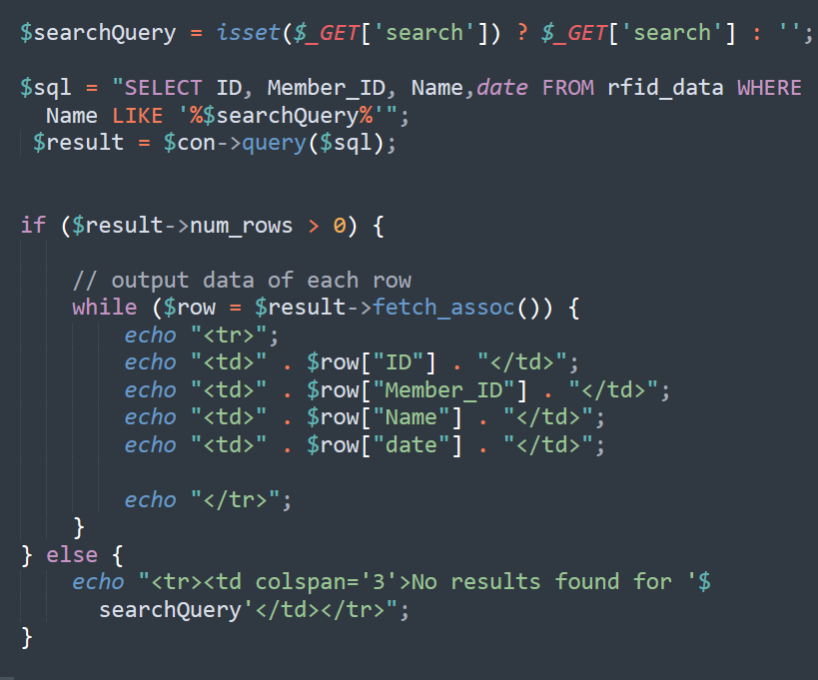

## 4.3 Budget

|  |  |  |  |
| --- | --- | --- | --- |
| No | Item | Quantity | Total Cost |
| 1 | MFRC 522 | 1 | MYR 9.90 |
| 2 | HC-SR501 | 1 | MYR 5.90 |
| 3 | ESP32-CAM | 1 | MYR 25.90 |
| 4 | Arduino Uno R3 | 1 | MYR 27.90 |
| 5 | Jumper | 1 | MYR 3.00 |
|  |  | Total | MYR 71.70 |

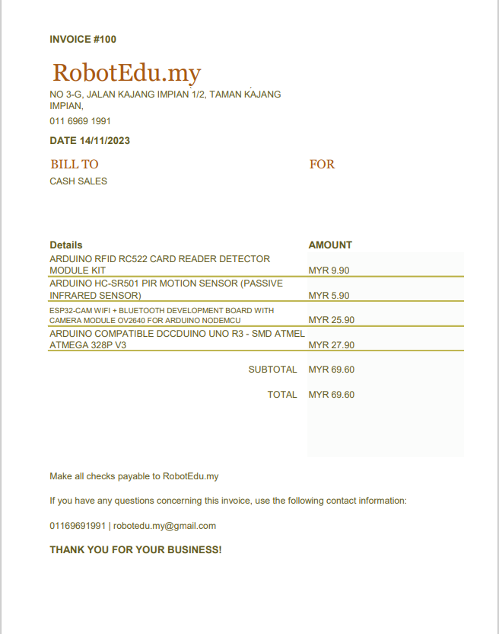

# Chapter 5 Testing Result

|  |  |
| --- | --- |
| Name | Website Access via XAMPP server |
| Requirement | Power on the Xampp server |
| Precondition | Laptop or pc use <http://localhost> or IP address to visit website |
| step | 1. Open Computer Or laptop 2. Open Xampp server 3. Open The Web Browser 4. In the search Bar key in server ip address or https://localhost |
| Expecting Results | Successfully access website |



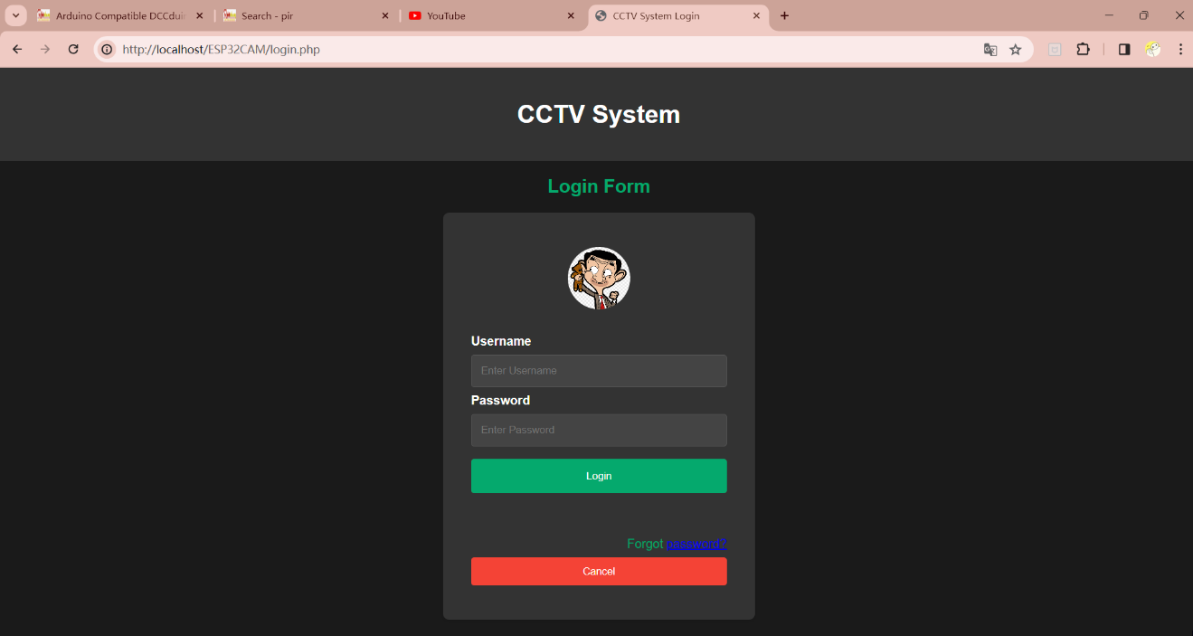

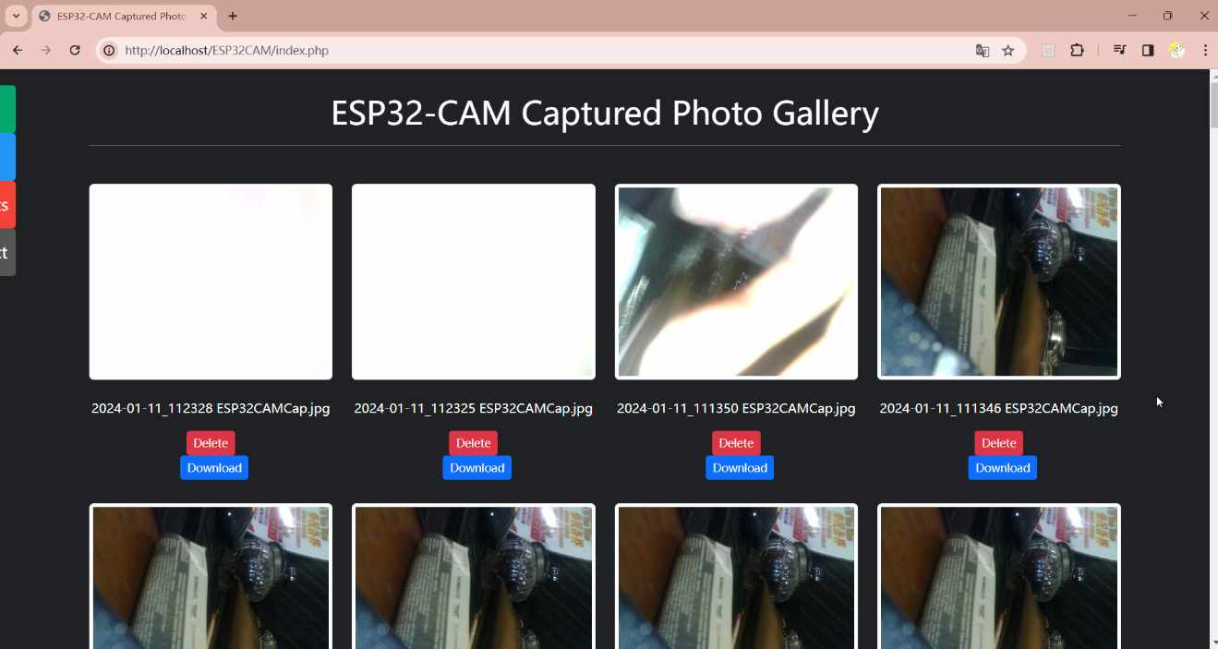

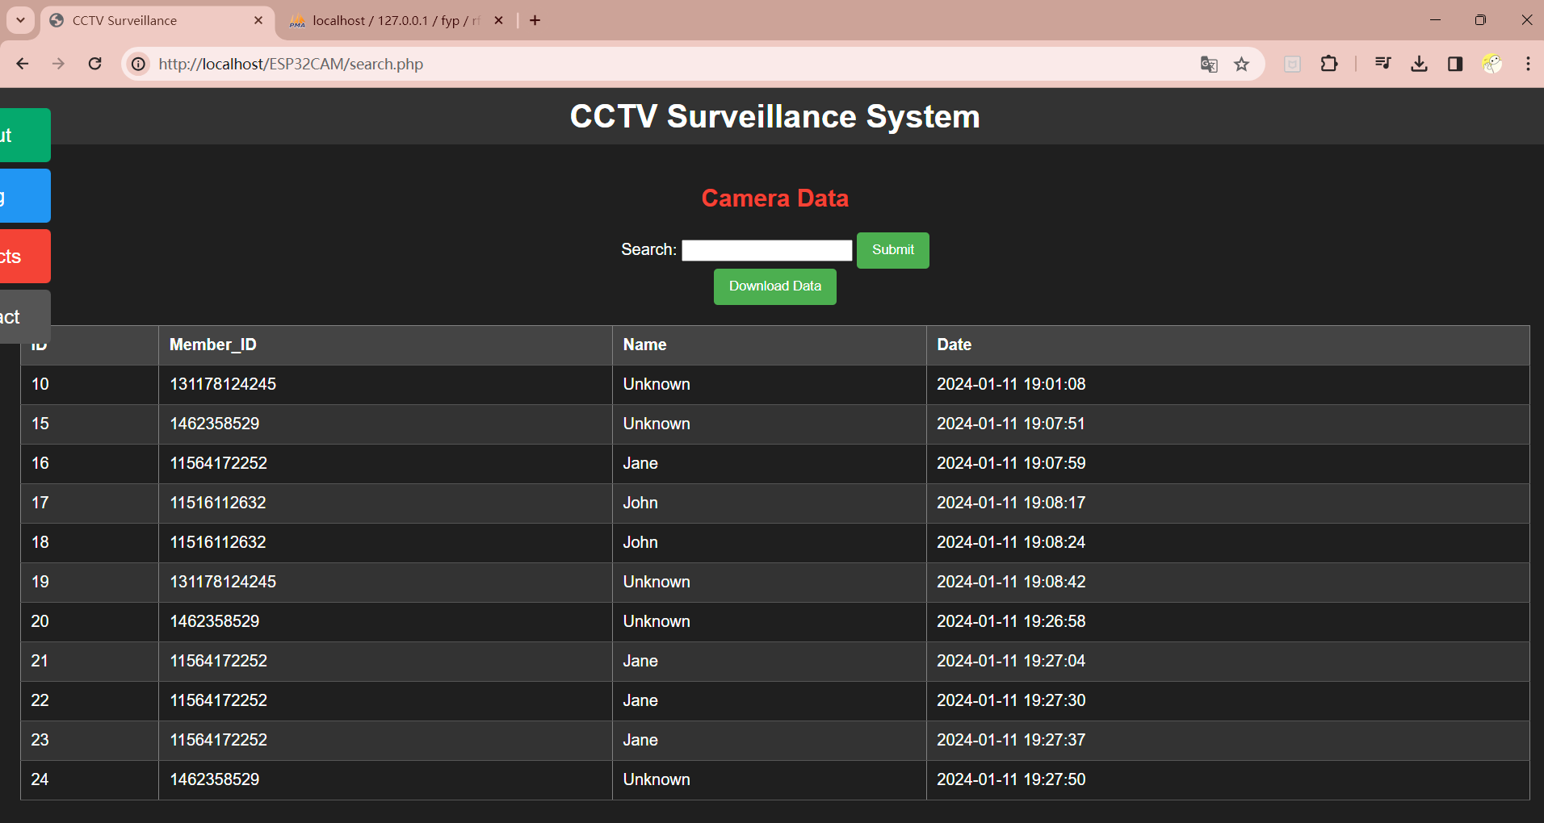

|  |  |
| --- | --- |
| Name | Website Login Functionality Verification |
| Requirement | Power on the Xampp server |
| Precondition | Laptop or pc use <http://localhost> or IP address to visit website |
| step | 1. Open Computer Or laptop 2. Open Xampp server 3. Open The Web Browser 4. In the search Bar key in server ip address or <https://localhost> 5. Type Username and Password 6. If the username and password correct can visit the website |
| Expecting Results | Successfully login with the correct username and password, allowing access to the website. |



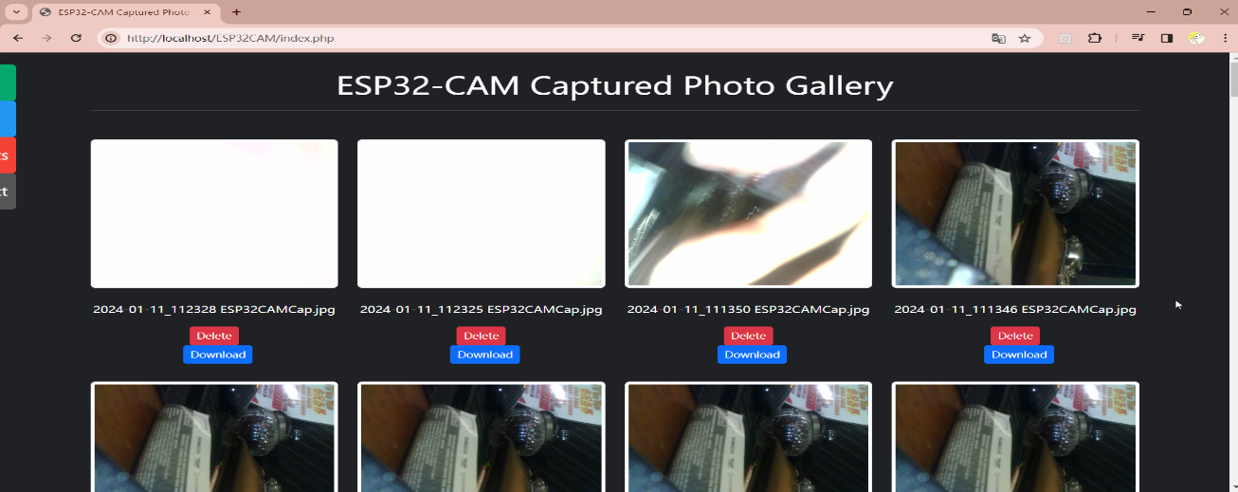

|  |  |
| --- | --- |
| Name | Website Login Functionality Verification (Failed Login) |
| Requirement | Power on the Xampp server |
| Precondition | Laptop or pc use <http://localhost> or IP address to visit website |
| step | 1. Open Computer Or laptop 2. Open Xampp server 3. Open The Web Browser 4. In the search Bar key in server ip address or <https://localhost> 5. Type Username and Password 6. If didn’t have the username and password login will be fail and will return to login page |
| Expecting Results | Block the user from accessing the site and return the user to the login page if the login is unsuccessful |



|  |  |
| --- | --- |
| Name | Delete Functionality Verification |
| Requirement | Login Website |
| Precondition | Laptop or pc use <http://localhost> or IP address to visit website |
| step | 1. Login Website 2. Selected the picture u want to delete. 3. After delete u will see the notification show out the details |
| Expecting Result | Photon can be successfully deleted |



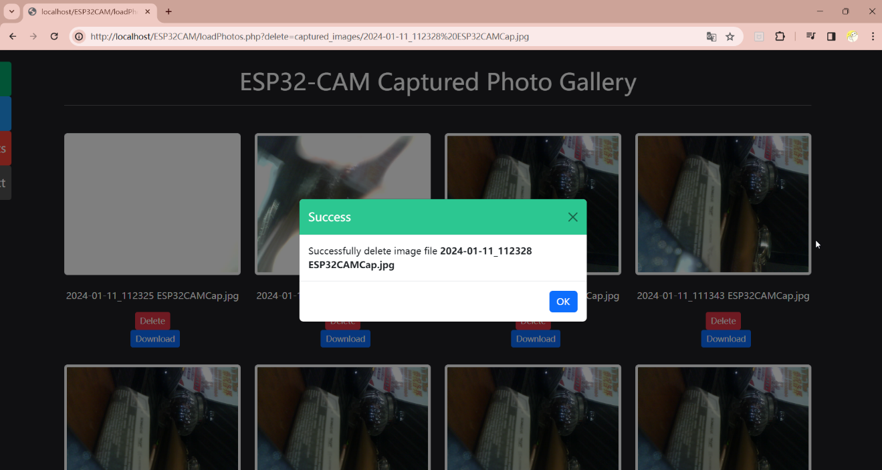

|  |  |
| --- | --- |
| Name | Download Functionality Verification |
| Requirement | Login Website |
| Precondition | Laptop or pc use <http://localhost> or IP address to visit website |
| step | 1. Login Website 2. Selected the picture u want to download. 3. After Download u will see the notification show out the download details |
| Excepting Result | Success download picture form the server |

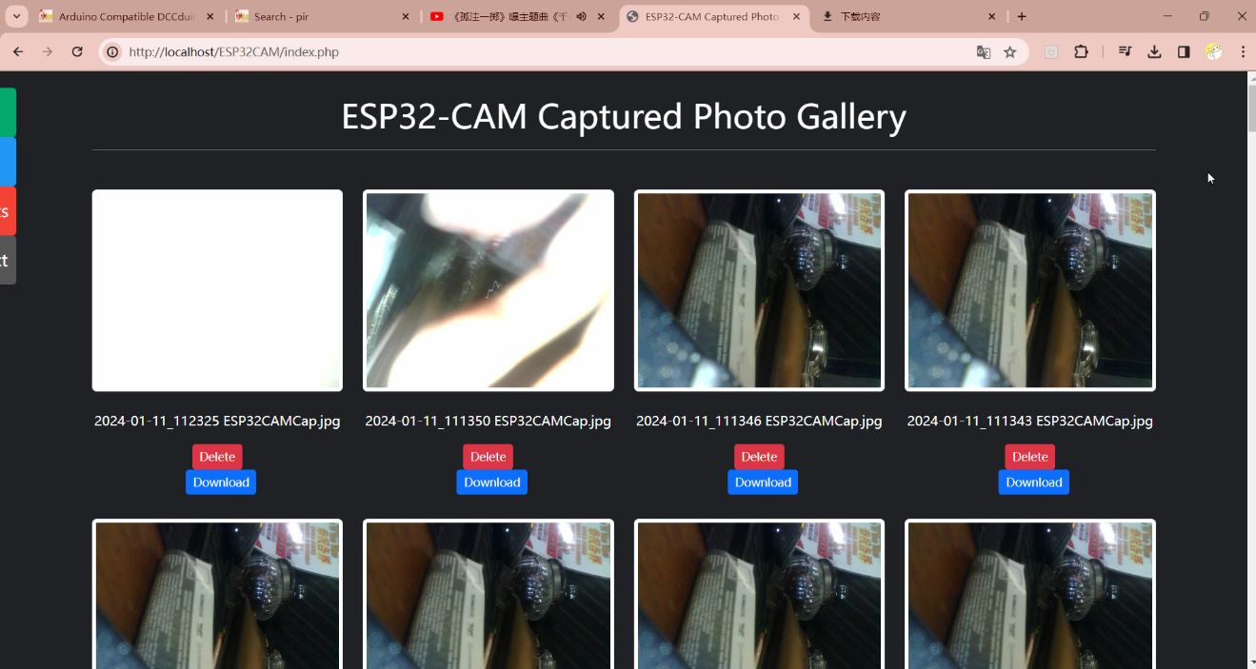

Download Function

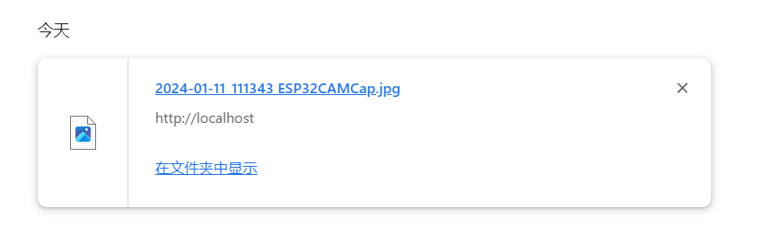

|  |  |
| --- | --- |
| Name | Search Functionality for Access Record Verification |
| Requirement | Login Website |
| Precondition | Laptop or pc use <http://localhost> or IP address to visit website |
| step | 1. Login Website 2. U will see the data at the webpage 3. U can search by name see who login at what time |
| Expecting Result | Success searches the access record form server |



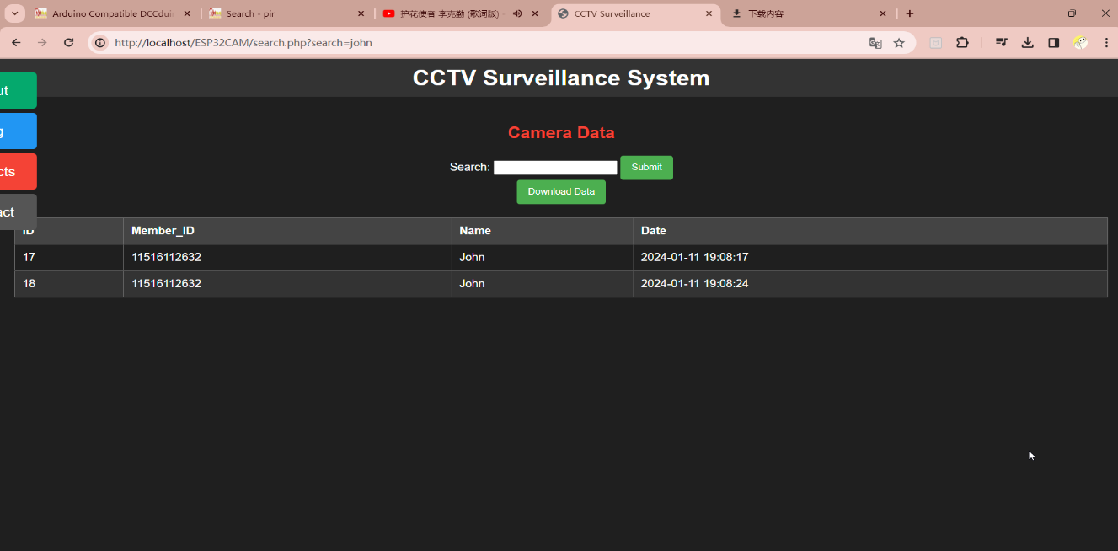

|  |  |
| --- | --- |
| Name | Access Data Download Function Test |
| Requirement | Login Website |
| Precondition | Laptop or pc use <http://localhost> or IP address to visit website |
| step | 1. Login Website 2. U will see the data at the webpage 3. U can search by name do download the access data for the personal or all |
| Expecting Result | Successfully download the access from the server |

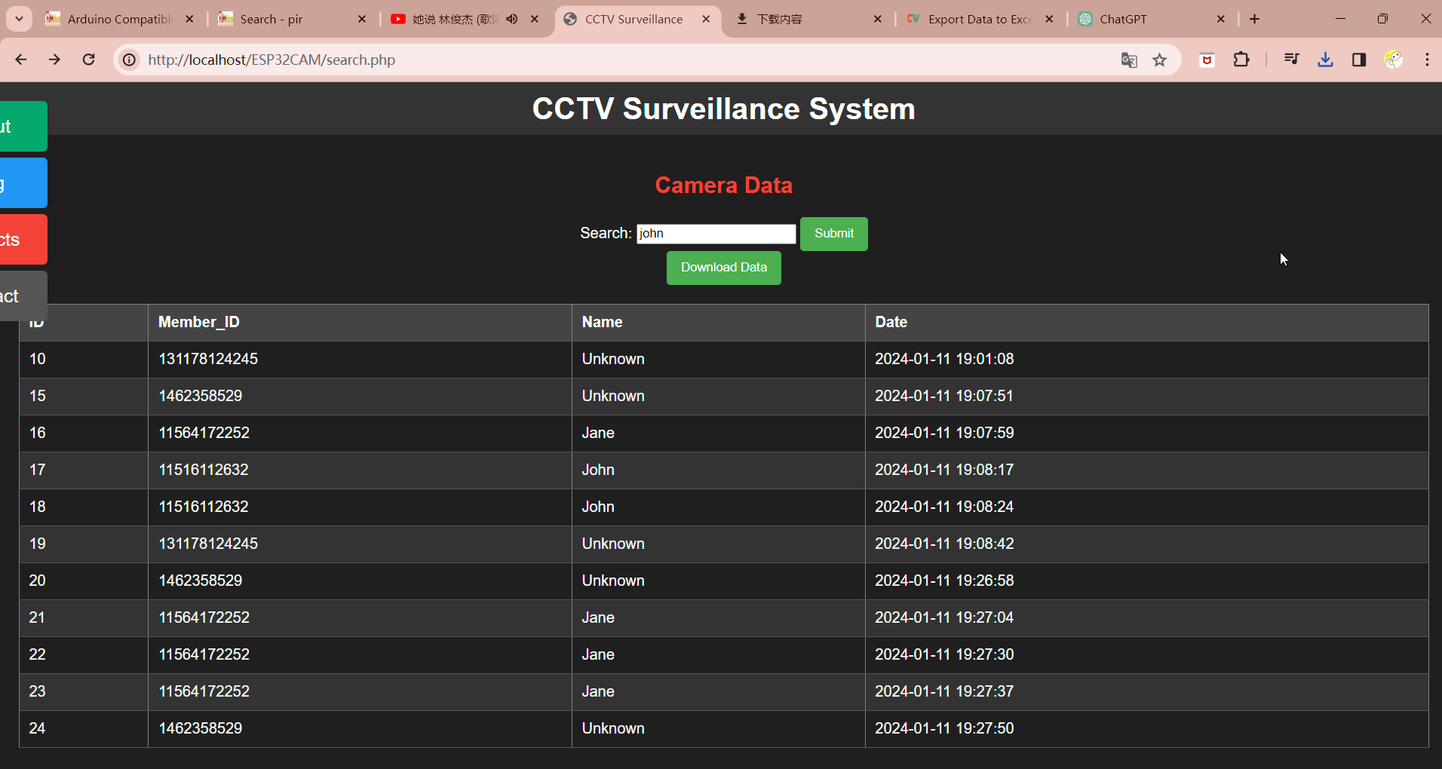

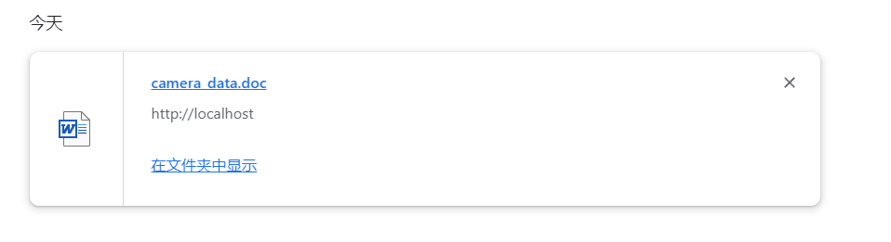

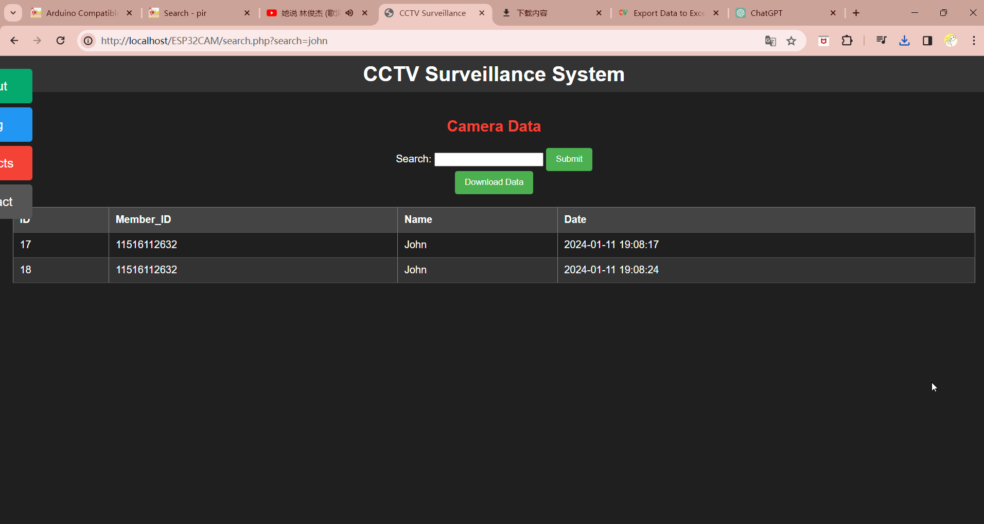

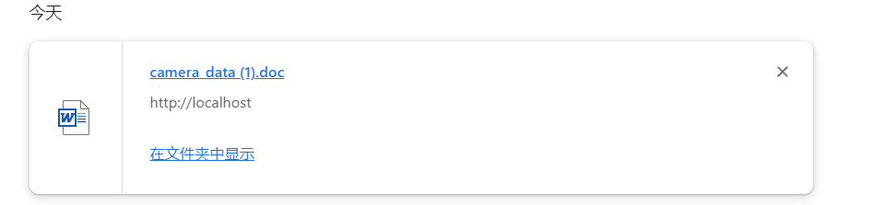

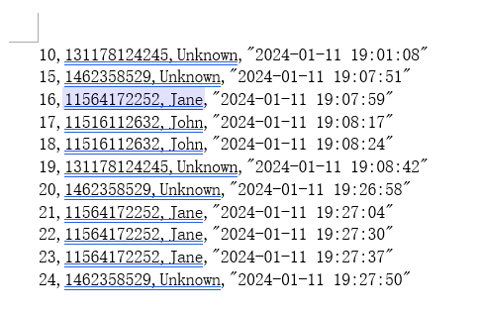

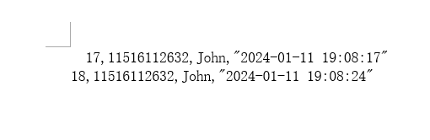

|  |  |
| --- | --- |
| Name | ESP32-cam Motion Detection Photo Capture and Upload |
| Requirement | input the power supply for ESP32 |
| Precondition | Laptop or pc use <http://localhost> or IP address to visit website |
| step | 1. Login Website 2. When have motion detection the website will refresh and send the photo to the server, we can visit the photo at the website |
| Expecting Result | ESP32 Success capture the picture and send to server display out the picture |



|  |  |
| --- | --- |
| Name | Arduino Uno R3 Power Supply to ESP32-CAM Test |
| Requirement | input the power supply for ESP32-cam |
| Precondition | The wiring is connected properly. |
| step | 1. Plug the Power Supply 2. Check The Light if working will light on |
| Expecting Result | The presence of the green light on ESP32-CAM indicates successful power supply from Arduino Uno R3. |

|  |  |
| --- | --- |
| Name | ESP32-CAM Functionality Test |
| Requirement | input the power supply for ESP32-cam |
| Precondition | Ensure the wiring is connected properly. |
| step | 1. Plug the Power Supply 2. Check The Light if working will light on 3. When have Motion detected will open flashlight |
| Expecting Result | The activation of the flashlight indicates that the ESP32-CAM is functioning properly. |

桌子上放了键盘

、

|  |  |
| --- | --- |
| Name | ESP32-CAM Wi-Fi Connection Test |
| Requirement | input the power supply for ESP32-cam |
| Precondition | The wiring is connected properly. |
| step | 1. Plug the Power Supply 2. Check The Light if working will light on. 3. If motion detected ready WhatsApp will receive “Hello from ESP32 “ |
| Expecting Result | When the ESP32 Success connect the WIFI the WhatsApp will receive the message from the esp32 |

|  |  |
| --- | --- |
| Name | ESP32-CAM Motion Detection WhatsApp Message Test |
| Requirement | input the power supply for ESP32-cam |
| Precondition | The wiring is connected properly. |
| step | 1. Plug the Power Supply 2. Check The Light if working will light on. 3. If motion detected ready WhatsApp will receive “Hello from ESP32 “ 4. If have motion detected WhatsApp will receive “ |
| Expecting Result | Successfully receiving a message from ESP32-CAM on WhatsApp upon motion detection indicates proper functionality of the ESP32-CAM. |

|  |  |
| --- | --- |
| Name | MFRC522 Data Recording and Database Upload Test |
| Requirement | input the power supply for MFRC522 |
| Precondition | Laptop or pc use <http://localhost> or IP address to visit website |
| step | 1. Login Website 2. When have access responded to the python script will send the card details to the server and record the time and the name and card id |
| Expecting Result | The MFRC522 successfully records the access data, sends it to the database, and the website displays the recorded data as required. |



|  |  |
| --- | --- |
| Name | MFRC522 Functionality Test |
| Requirement | input the power supply for MFRC522 |
| Precondition | The wiring is connected properly. |
| step | 1. Plug the Power Supply 2. Check The Light if working will light on |
| Expecting Result | The presence of the red light on MFRC522 indicates successful functionality. |

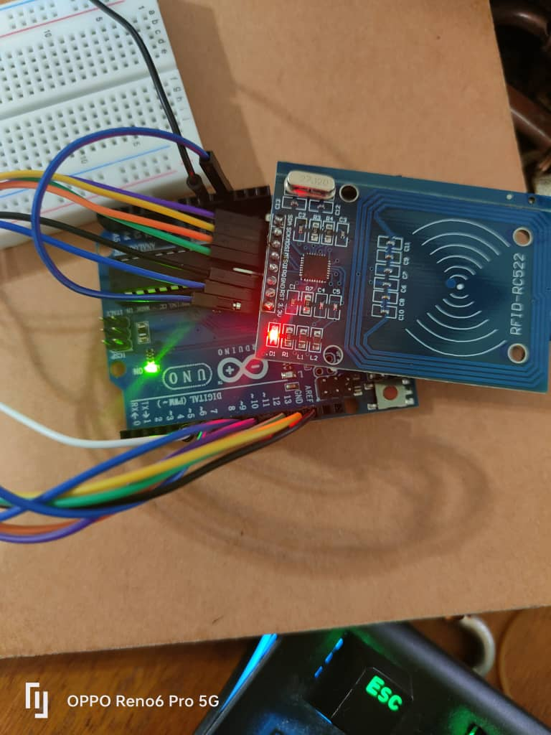

|  |  |
| --- | --- |
| Name | RFID Card Validation with MFRC522 |
| Requirement | input the power supply for MFRC522 |
| Precondition | The wiring is connected properly. |
| step | 1. Plug the Power Supply 2. Check The Light if working will light on 3. If Have the User, The Light Will Light of with Green 4. If didn’t have the user the light will light of with red |
| Expecting Result | Successful validation of a valid RFID card should result in a green light indication. An invalid RFID card should result in a red-light indication. |

When an RFID card is valid in the system, the light will be green.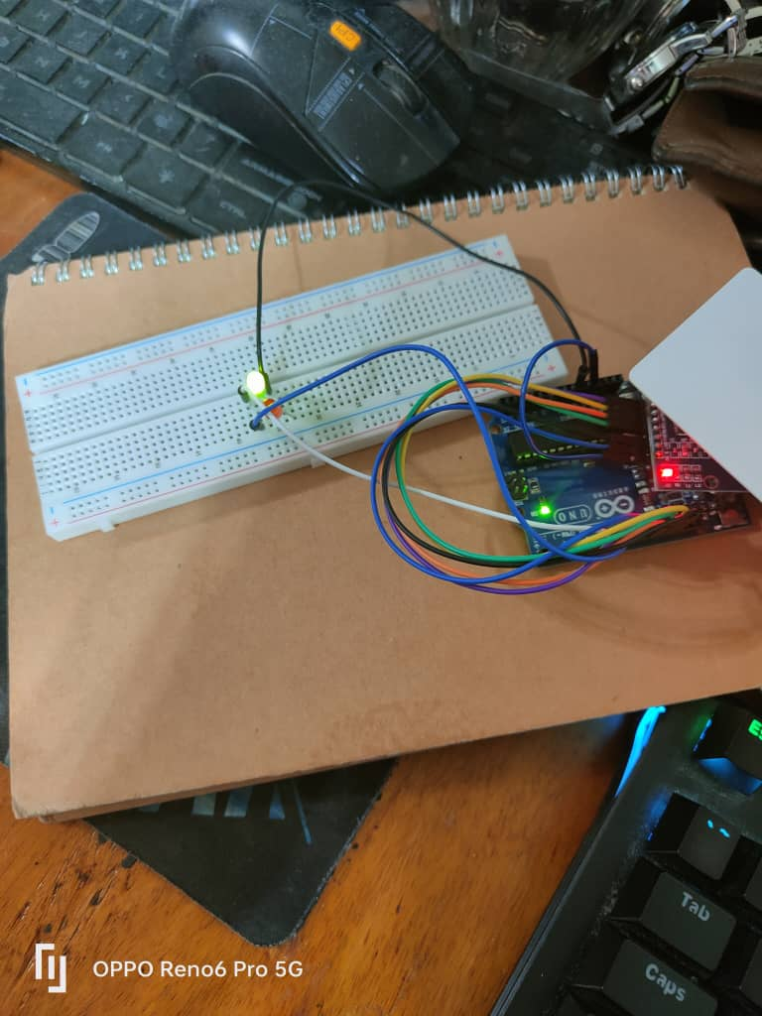

When an RFID card is invalid in the system, the light will be red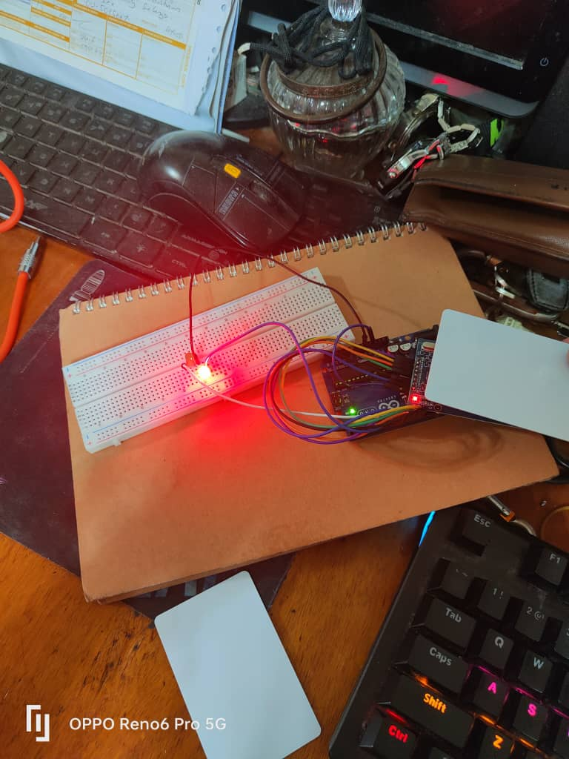

|  |  |
| --- | --- |
| Name | User Authentication with MFRC522 RFID Validation (Valid) |
| Requirement | input the power supply for MFRC522 |
| Precondition | The wiring is connected properly. |
| step | 1. Plug the Power Supply 2. Check The Light if working will light on 3. RFID will read the data in the card and if the card data matches the system record it will display the name of the card holder and upload the data to the server. |
| Expecting Result | Upon successful card access, the system should display the card number and the owner's name. |

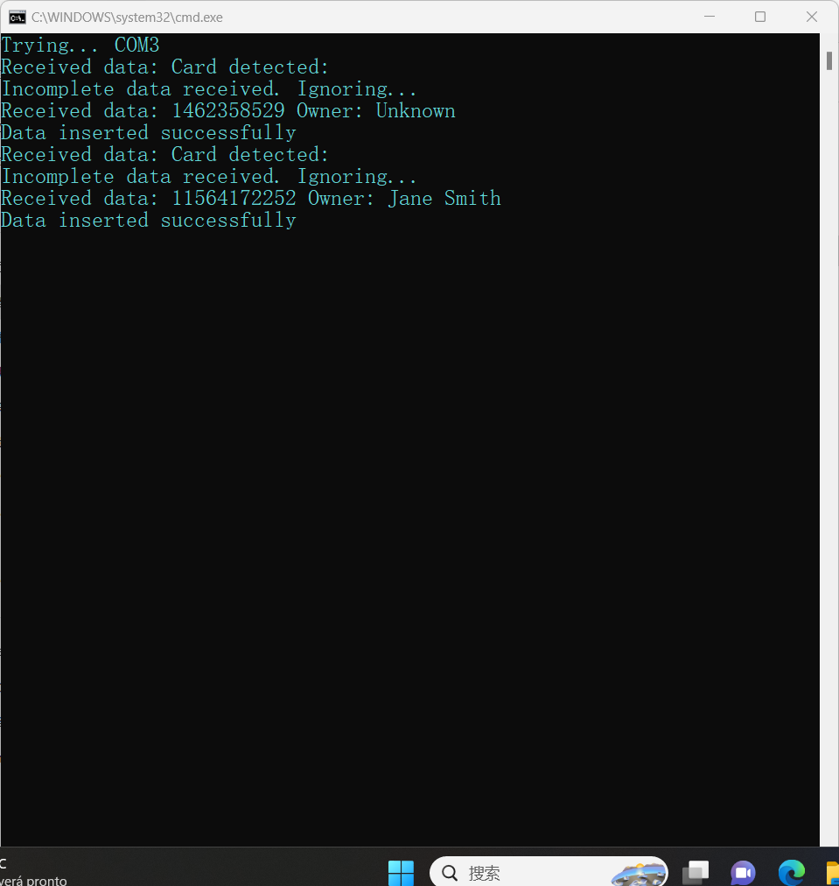

|  |  |
| --- | --- |
| Name | User Authentication with MFRC522 RFID Validation (Invalid) |
| Requirement | input the power supply for MFRC522 |
| Precondition | The wiring is connected properly. |
| step | 1. Plug the Power Supply 2. Check The Light if working will light on 3. The RFID will read the data in the card and if the data in the card does not match with the system, it will display the card number and the card holder will be unknown. |
| Expecting Result | The user's access to the system should be unsuccessful, indicated by the display of the card number and the card holder as "unknown" when the data in the card does not match the system records. |



# Chapter 6 Future Enhancements

By comprehensively reviewing the objectives, methodology, and key results achieved throughout the project, I successfully completed parts 1, 2, and 3 of the projects. I fully realized the stated objectives and scope of the project after serious effort.

My have thought deeply about where I want to go with future improvements and plan to focus on enhancing the performance, functionality, and user experience of the project. Specifically, i will focus on the following areas of enhancement:

1. Optimization of procedures: As we can see from the code in the picture, when we use the ESP32-CAM to send messages, we use a web page called api.callmebot. I hope that someday we will be able to use the message sending program that comes with the ESP32-CAM. 图形用户界面, 文本, 应用程序

   描述已自动生成
2. Expansion: In the future, we can try to combine the fingerprint authenticator with RFID to realize the dual authentication of access control and motion detection system. And on top of that, we can add a display to show who the user is when he scans it and so on.
3. User Experience Improvement: Currently I use web to view the history in the future, I hope I can use APP to view photos and access control records anytime and anywhere. I hope that in the future we can use more social software to get motion detection information, and I hope that in the future the clarity of the camera can be more clear.

# Chapter 7 Summary and Conclusion

This section presents an overall view of the starting point, objectives and implementation of the project. Through this project, I have solved some problems and at the same time I have learned a lot and gained valuable experience. The following are the things I have learned in Project:

1. Getting to know the circuits.
2. How to connect to the server
3. How to edit web pages using code
4. Learning a new programming language

I briefly described the conceptualization and implementation of the project and highlighted some of the major choices made and achievements made during the course of the project. In the process I learned to be careful about connecting circuits or risk shorting out the board by plugging in wires by mistake.

Finally, I have considered the future of the project and made some recommendations for continued growth and success. In the future, attention can be paid to continuous learning and incorporating user feedback to continually improve and expand the project's functionality to adapt to changing needs and technological environments. By doing so, the project will be able to remain viable, evolve, and achieve greater success.

# **Appendices**

## Reference

[1]**Embedotronics Technologies** [Online] // Youtube. - Jul 14, 2019. - https://www.youtube.com/watch?v=aUHDtCRmVIo&ab_channel=EmbedotronicsTechnologies.

**[2]ESP32: Send Messages to WhatsApp** [Online] // Random Nerd Tutorials. - https://randomnerdtutorials.com/esp32-send-messages-whatsapp/.

**[3]ESP32-CAM Blynk PIR Motion Sensor HC-SR501 with LINE Notify** [Online] // elec.cafe.com. - https://www.elec-cafe.com/esp32-cam-blynk-pir-motion-sensor-hc-sr501-with-line-notify/.

**[4]Uteh Str** Arduino IDE + ESP32 CAM + Server | ESP32-CAM Capture and Send or Post Photos to Server [Online] // Youtube. - Uteh Str, Feb 28, 2023. - https://www.youtube.com/watch?v=WHjhRya_16k&ab_channel=UtehStr.

## PROJECT PROPOSAL FORM

**Student name: Mah Sung Kit**

**Student ID No: 2220035 Email Address:mahsungkit0816@e.neivce.edu.my**

**Project title: RFID and Motion Detection Based Access System**

**Supervisor: Mr. Gan Boon Siang**

**Brief description of project:**

A security system is a comprehensive set of measures and components designed to safeguard individuals, assets, or information from various threats, risks, and unauthorized access. The primary goal of a security system is to provide protection and ensure the safety of people and valuable resources.

In this project, an ESP32 microcontroller will be used to construct a security system that combines RFID access control and motion detection features. The Arduino IDE will be used to configure the ESP32 to control access using RFID cards and use sensors to detect movements.

The principal aim of this project is to proficiently leverage ESP32 microcontrollers for the implementation of motion detection and RFID-based access control, thereby substantially enhancing overall security. The key features of this system include photo-access recording, a comprehensive database for checking historical access data, and the integration of a user-friendly web GUI or another interface. Through these enhancements, the project seeks to elevate the quality of security measures, ensuring a robust and efficient solution for diverse applications

Designed with versatility in mind, this project finds practical applications in various settings including home security, offices, industrial facilities, school teachers' offices, and server rooms. The proposed devices can be strategically placed at the entry points of buildings, offering a comprehensive security solution that addresses the unique needs of diverse environments.

The Supervisor and Project Manager should sign in the space provided below to indicate that the necessary resources (including supervision time/expertise) are available for the proposal.

Student Signature: ..........................................................................................

Project Manager Signature: .........................................................................................

Date: ................................................

## PROJECT SPECIFICATION FORM (PSF)

**Student name: Mah Sung Kit Student ID No: 2220035**

**Intake: FEB/22 Email Address: mahsungkit0816@e.neivce.edu.my**

**Project title: RFID and Motion Detection Based Access System**

**Supervisor: Mr. Gan Boon Sinag**

**Brief description of project:**

1. Brief description of project background.

Embarking on a project that converges Arduino as the core device in a prototypical setup, my primary goal is to explore security concepts within the realm of physical security. The project serves as a valuable opportunity to study and learn, utilizing an ESP32 microcontroller to construct a security system. This system seamlessly integrates RFID access control and motion detection features, all orchestrated through the Arduino IDE, contributing to a hands-on and comprehensive understanding of security principles in a practical context.

In this project, an ESP32 microcontroller will be used to construct a security system that combines RFID access control and motion detection features. The Arduino IDE will be used to configure the ESP32 to control access using RFID cards and use sensors to detect movements.

1. Brief description of project objectives.

Implementing motion detection, RFID-based security access, and notification features are all included in the scope.

1. Motion Detection – Detects motion in the designated area
2. Camera motion - Captures images in response to detected motion
3. RFID-Based Access - Controls access based on RFID card authentication.
4. Access Record - Records information about access events.
5. View access record - Gui with photo - Provides a graphical interface to view access records, including associated photos.
6. Notification features - Sends notifications for specific events. To email
7. View access record – GUI - Allows users to view access records in a graphical format.
8. Brief description of the resources needed by the proposal.  
   (i.e. hardware, software, access to information/expertise, user involvement etc.)

Hardware :

1. Arduino
2. ESP 32
3. Motion Detection
4. MFRC522 RFID Reader

Software:

1. Arduino IDE
2. XAMPP
3. Power Point
4. Microsoft Word

User involvement:

1. Project Supervisor -MR. Gan Boon Siang
2. Project member – Mah sung kit

Information

1. Project information - Google search engine
2. Project information – Random Nerd Tutorials
3. Academic research being carried out and other information, techniques being learnt. (i.e. What are the names of the books you are going to read / data sets you are going to use and why.)

Main reference – Security Access using MFRC522 RFID Reader with Arduino (<https://randomnerdtutorials.com/security-access-using-mfrc522-rfid-reader-with-arduino/)>

Reason – I will refer to this page to complete my RFID access control system

Other Reference - **ESP32 Motion Detection with Notifications (Arduino IDE)**

([https://randomnerdtutorials.com/telegram-esp32-motion-detection-arduino/#more-97919](https://randomnerdtutorials.com/telegram-esp32-motion-detection-arduino/%23more-97919))

Reason - I will refer to this page to complete my motion detection system and alert notification system

1. Brief description of the development plan for the proposed project.  
   (i.e. which software methodology and why, the major areas or functions to be developed and the order in which they will be developed)
2. Search reference / online research
3. Set up the ESP32 by configuring it and connecting its peripherals.
4. Motion Detection: Motion sensor implementation code.
5. RFID access control: To achieve RFID functionality, an integrated MFRC522 card reader is used.
6. Notification system: Send logs and set alerts for motion detection.
7. Testing, issue fixes, and component assembly comprise integration.
8. Documentation
9. Project presentation
10. Brief description of the evaluation and test plan for the proposed project.  
    (i.e. what is the success criteria and how will be evaluated & implementation will be tested)

Success Standards:

1. Motion detection is the precise recognition of motion-related events.
2. RFID Access Control: RFID cards that are reliably authenticated.
3. Notifications: Accurate and timely alerts when motion is detected.

Examine:

1. To confirm motion detection and access control, use simulated devices.
2. testing in comparison with well-known RFID cards.
3. Testing of notifications through various channels of communication (e.g., email, SMS)
4. Test the back-end logging system of the web page, the storage of photos system is functioning correctly

Test Plan:

1. Unit tests target individual components.
2. Integration tests target combined functionality.
3. Ensure that the page works and view the logs

By adhering to predetermined standards for motion detection, RFID access control, and alerts, this all-encompassing strategy seeks to guarantee the effective creation and assessment of the security system.

The Supervisor and Project Manager should sign in the space provided below to indicate that the necessary resources (including supervision time/expertise) are available for the proposal.

Supervisor’s signature: .......................................................................

Date: ..............................

## **Project Weekly Report**

**Project Weekly Report 1**

**Notes on use of the weekly report**

1. This report is designed for meeting of more than 10 minutes duration, of which there should be at least ten during the course of the project.

2. The student should prepare for the supervisory meeting by deciding which questions he or she needs to ask the supervisor and what progress has been made (if any) since the last meeting and noting these in the relevant sections of the form, effectively forming an agenda for the meeting;

3. The business of the meeting should be noted briefly in the relevant section of the form;

4. The actions on the student (and, perhaps the supervisor), which should be carried out before the next meeting should be noted briefly in the relevant section of the form;

5. The report is one of the deliverables from the project and is an important record of the student's organisation and learning experience. The student should ensure that it is handed in as an appendix of the report, with sheets dated and numbered consecutively;

_________________________________________________________________________

**Student's name**:Mah Sung Kit **Date: 11/16/2023 Sheet no.1**

**Project title**: **RFID and Motion Detection Based Access System**

**Supervisor’s name**: Mr. Gan Boon Siang

**Report:**

1. **Do a online research**
2. **Writing project proposal**
3. **Search for product information already priced**
4. **Discuss the topic with your supervisor**

Student Signature: ..........................................................................................

Supervisor Signature: .........................................................................................

Date: ................................................

**Project Weekly Report 2**

**Notes on use of the weekly report**

1. This report is designed for meeting of more than 10 minutes duration, of which there should be at least ten during the course of the project.

2. The student should prepare for the supervisory meeting by deciding which questions he or she needs to ask the supervisor and what progress has been made (if any) since the last meeting and noting these in the relevant sections of the form, effectively forming an agenda for the meeting;

3. The business of the meeting should be noted briefly in the relevant section of the form;

4. The actions on the student (and, perhaps the supervisor), which should be carried out before the next meeting should be noted briefly in the relevant section of the form;

5. The report is one of the deliverables from the project and is an important record of the student's organisation and learning experience. The student should ensure that it is handed in as an appendix of the report, with sheets dated and numbered consecutively;

_________________________________________________________________________

**Student's name**: Mah Sung Kit **Date: 22/11/2023 Sheet no.2**

**Project title**: **RFID and Motion Detection Based Access System**

**Supervisor’s name**: Mr.Gan Boon Siang

**Report:**

1. **Go buy what you need for the project**
2. **Writing Project Specification**
3. **Discuss the topic with your supervisor**

Student Signature: ..........................................................................................

Supervisor Signature: .........................................................................................

Date: ................................................

**Project Weekly Report 3**

**Notes on use of the weekly report**

1. This report is designed for meeting of more than 10 minutes duration, of which there should be at least ten during the course of the project.

2. The student should prepare for the supervisory meeting by deciding which questions he or she needs to ask the supervisor and what progress has been made (if any) since the last meeting and noting these in the relevant sections of the form, effectively forming an agenda for the meeting;

3. The business of the meeting should be noted briefly in the relevant section of the form;

4. The actions on the student (and, perhaps the supervisor), which should be carried out before the next meeting should be noted briefly in the relevant section of the form;

5. The report is one of the deliverables from the project and is an important record of the student's organisation and learning experience. The student should ensure that it is handed in as an appendix of the report, with sheets dated and numbered consecutively;

_________________________________________________________________________

**Student's name**: Mah Sung Kit **Date: 26/11/2023 Sheet no. 3**

**Project title**: **RFID and Motion Detection Based Access System**

**Supervisor’s name** Mr. Gan Boon Siang

**Report:**

1. **Research Motion Detection System**
2. **Study how esp32 works and take pictures**

Student Signature: ..........................................................................................

Supervisor Signature: .........................................................................................

Date: ................................................

**Project Weekly Report 4**

**Notes on use of the weekly report**

1. This report is designed for meeting of more than 10 minutes duration, of which there should be at least ten during the course of the project.

2. The student should prepare for the supervisory meeting by deciding which questions he or she needs to ask the supervisor and what progress has been made (if any) since the last meeting and noting these in the relevant sections of the form, effectively forming an agenda for the meeting;

3. The business of the meeting should be noted briefly in the relevant section of the form;

4. The actions on the student (and, perhaps the supervisor), which should be carried out before the next meeting should be noted briefly in the relevant section of the form;

5. The report is one of the deliverables from the project and is an important record of the student's organisation and learning experience. The student should ensure that it is handed in as an appendix of the report, with sheets dated and numbered consecutively;

_________________________________________________________________________

**Student's name**: Mah Sung Kit **Date: 02/12/2023 Sheet no.4**

**Project title**: **RFID and Motion Detection Based Access System**

**Supervisor’s name**: Mr. Gan Boon Siang

**Report:**

1. **Studying the workings of the code**
2. **Researching how to upload Data to the database**
3. **Procurement of missing equipment**

Student Signature: ..........................................................................................

Supervisor Signature: .........................................................................................

Date: ................................................

**Project Weekly Report 5**

**Notes on use of the weekly report**

1. This report is designed for meeting of more than 10 minutes duration, of which there should be at least ten during the course of the project.

2. The student should prepare for the supervisory meeting by deciding which questions he or she needs to ask the supervisor and what progress has been made (if any) since the last meeting and noting these in the relevant sections of the form, effectively forming an agenda for the meeting;

3. The business of the meeting should be noted briefly in the relevant section of the form;

4. The actions on the student (and, perhaps the supervisor), which should be carried out before the next meeting should be noted briefly in the relevant section of the form;

5. The report is one of the deliverables from the project and is an important record of the student's organisation and learning experience. The student should ensure that it is handed in as an appendix of the report, with sheets dated and numbered consecutively;

_________________________________________________________________________

**Student's name**: Mah Sung Kit **Date: 13/12/2023 Sheet no.5**

**Project title**: **RFID and Motion Detection Based Access System**

**Supervisor’s name**:Mr. Gan Boon Siang

**Report:**

1. **Studying the workings of the code**

**2）Perform basic configuration of RFID access control and test RFID access control for proper operation**

**3）Basic configuration of Motion detected and testing of Motion detected to see if it works.**

Student Signature: ..........................................................................................

Supervisor Signature: .........................................................................................

Date: ................................................

**Project Weekly Report 6**

**Notes on use of the weekly report**

1. This report is designed for meeting of more than 10 minutes duration, of which there should be at least ten during the course of the project.

2. The student should prepare for the supervisory meeting by deciding which questions he or she needs to ask the supervisor and what progress has been made (if any) since the last meeting and noting these in the relevant sections of the form, effectively forming an agenda for the meeting;

3. The business of the meeting should be noted briefly in the relevant section of the form;

4. The actions on the student (and, perhaps the supervisor), which should be carried out before the next meeting should be noted briefly in the relevant section of the form;

5. The report is one of the deliverables from the project and is an important record of the student's organisation and learning experience. The student should ensure that it is handed in as an appendix of the report, with sheets dated and numbered consecutively;

_________________________________________________________________________

**Student's name**: Mah Sung Kit **Date: 19/12/2023 Sheet no.6**

**Project title**: **RFID and Motion Detection Based Access System**

**Supervisors name**:Mr. Gan Boon Siang

**Report:**

1. **Studying the workings of the code**

**2）Adjusting the motion detecteor sensitivity**

**3）Study uploading images to database through esp 32**

Student Signature: ..........................................................................................

Supervisor Signature: .........................................................................................

Date: ................................................

**Project Weekly Report 7**

**Notes on use of the weekly report**

1. This report is designed for meeting of more than 10 minutes duration, of which there should be at least ten during the course of the project.

2. The student should prepare for the supervisory meeting by deciding which questions he or she needs to ask the supervisor and what progress has been made (if any) since the last meeting and noting these in the relevant sections of the form, effectively forming an agenda for the meeting;

3. The business of the meeting should be noted briefly in the relevant section of the form;

4. The actions on the student (and, perhaps the supervisor), which should be carried out before the next meeting should be noted briefly in the relevant section of the form;

5. The report is one of the deliverables from the project and is an important record of the student's organisation and learning experience. The student should ensure that it is handed in as an appendix of the report, with sheets dated and numbered consecutively;

_________________________________________________________________________

**Student's name**:Mah Sung Kit **Date: 26/12/2023 Sheet no. 7**

**Project title**: **RFID and Motion Detection Based Access System**

**Supervisor’s name**:Mr. Gan Boon Siang

**Report:**

1. **Trying to Write code for esp32-cam**
2. **Discuss with your teacher the use of the ESP32-cam or the ESP32-cam and FTDI Program.**
3. **Modify the code of esp32-cam**

Student Signature: ..........................................................................................

Supervisor Signature: .........................................................................................

Date: ................................................

**Project Weekly Report 8**

**Notes on use of the weekly report**

1. This report is designed for meeting of more than 10 minutes duration, of which there should be at least ten during the course of the project.

2. The student should prepare for the supervisory meeting by deciding which questions he or she needs to ask the supervisor and what progress has been made (if any) since the last meeting and noting these in the relevant sections of the form, effectively forming an agenda for the meeting;

3. The business of the meeting should be noted briefly in the relevant section of the form;

4. The actions on the student (and, perhaps the supervisor), which should be carried out before the next meeting should be noted briefly in the relevant section of the form;

5. The report is one of the deliverables from the project and is an important record of the student's organisation and learning experience. The student should ensure that it is handed in as an appendix of the report, with sheets dated and numbered consecutively;

_________________________________________________________________________

**Student's name**: Mah Sung Kit **Date: 2/1/2024 Sheet no. 8**

**Project title**: **RFID and Motion Detection Based Access System**

**Supervisor’s name**: Mr. Gan Boon Siang

**Report:**

1. **Modifying Circuit Thinking**
2. **Purchase of missing parts**
3. **Try checking and repairing the electrical board**

Student Signature: ..........................................................................................

Supervisor Signature: .........................................................................................

Date: ................................................

**Project Weekly Report 9**

**Notes on use of the weekly report**

1. This report is designed for meeting of more than 10 minutes duration, of which there should be at least ten during the course of the project.

2. The student should prepare for the supervisory meeting by deciding which questions he or she needs to ask the supervisor and what progress has been made (if any) since the last meeting and noting these in the relevant sections of the form, effectively forming an agenda for the meeting;

3. The business of the meeting should be noted briefly in the relevant section of the form;

4. The actions on the student (and, perhaps the supervisor), which should be carried out before the next meeting should be noted briefly in the relevant section of the form;

5. The report is one of the deliverables from the project and is an important record of the student's organisation and learning experience. The student should ensure that it is handed in as an appendix of the report, with sheets dated and numbered consecutively;

_________________________________________________________________________

**Student's name**: Mah Sung Kit **Date: 7/1/2024 Sheet no. 9**

**Project title**: **RFID and Motion Detection Based Access System**

**Supervisor’s name**: Mr. Gan Boon Siang

**Report:**

1. **Welding MRFC522**
2. **Create web pages to give users a better viewing experience**
3. **Writing code for RFID Access card**

Student Signature: ..........................................................................................

Supervisor Signature: .........................................................................................

Date: ................................................

**Project Weekly Report 10**

**Notes on use of the weekly report**

1. This report is designed for meeting of more than 10 minutes duration, of which there should be at least ten during the course of the project.

2. The student should prepare for the supervisory meeting by deciding which questions he or she needs to ask the supervisor and what progress has been made (if any) since the last meeting and noting these in the relevant sections of the form, effectively forming an agenda for the meeting;

3. The business of the meeting should be noted briefly in the relevant section of the form;

4. The actions on the student (and, perhaps the supervisor), which should be carried out before the next meeting should be noted briefly in the relevant section of the form;

5. The report is one of the deliverables from the project and is an important record of the student's organisation and learning experience. The student should ensure that it is handed in as an appendix of the report, with sheets dated and numbered consecutively;

_________________________________________________________________________

**Student's name**: Mah Sung Kit **Date: 8/1/2024 Sheet no.10**

**Project title**: **RFID and Motion Detection Based Access System**

**Supervisor’s name**: Mr. Gan Boon Siang

**Report:**

1. **Consultation with teachers**
2. **Optimized code**

Student Signature: ..........................................................................................

Supervisor Signature: .........................................................................................

Date: ................................................

**Project Weekly Report 11**

**Notes on use of the weekly report**

1. This report is designed for meeting of more than 10 minutes duration, of which there should be at least ten during the course of the project.

2. The student should prepare for the supervisory meeting by deciding which questions he or she needs to ask the supervisor and what progress has been made (if any) since the last meeting and noting these in the relevant sections of the form, effectively forming an agenda for the meeting;

3. The business of the meeting should be noted briefly in the relevant section of the form;

4. The actions on the student (and, perhaps the supervisor), which should be carried out before the next meeting should be noted briefly in the relevant section of the form;

5. The report is one of the deliverables from the project and is an important record of the student's organisation and learning experience. The student should ensure that it is handed in as an appendix of the report, with sheets dated and numbered consecutively;

_________________________________________________________________________

**Student's name**: Mah Sung Kit **Date: 8/1/2024 Sheet no.11**

**Project title**: **RFID and Motion Detection Based Access System**

**Supervisor’s name**: Mr. Gan Boon Siang

**Report:**

1. **Writing A Report**
2. **Fix The Bug**

Student Signature: ..........................................................................................

Supervisor Signature: .........................................................................................

Date: ................................................

**Final Year Project Document Softcopy**

Google Drive Link: https://drive.google.com/drive/folders/1XuLTAaOhsJAbqweHQ5_ak3O-ITRC9FYG?usp=drive_link

Google Drive QR CODE:

